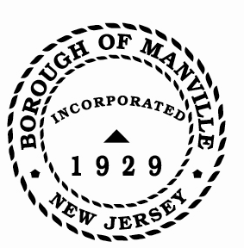
Borough of Manville
Resolution # 2025-11
Standing Committee Meeting Schedule

WHEREAS, in 2020, the Mayor & Council adopted Resolution # 2020-11 approving the concept to hold Standing Committee meetings on the first and third Mondays of the month following a recommendation by the PPP Committee to implement a set schedule to alleviate scheduling difficulties; and

WHEREAS, the standing Committees adhered to a monthly meeting schedule during 2020 and utilizing a set schedule was deemed to be beneficial ensuring Committees met regularly.

NOW, THEREFORE, BE IT RESOLVED by the Mayor and Council of the Borough of Manville, County of Somerset, and State of New Jersey that the Standing Committee meetings will be scheduled as follows:

First Monday of Every Month
Finance 5:00-6:00 pm
Progress & Development 6:00- 7:00 p.m.
Policy, Planning & Personnel 7:00 - 8:00 p.m.

Third Monday of Every Month
Public Safety 4:30- 5:30 p.m.
Public Works 5:45- 6:30 p.m.
Buildings and Grounds 6:30 - 7:30 p.m.

BE IT FURTHER RESOLVED that the Mayor and Council acknowledge that there may be revisions made occasionally to this schedule by the Borough Administrator in consultation with the Committee Chairperson.

ATTEST:

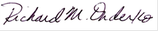
_________________
William Bray, RMC, CMR Richard M. Onderko
Borough Clerk Mayor

Introduced | Seconded | Council Members | Yes | No | Abstain | Absent
X |  | Councilwoman Camacho | X
 |  | Councilman DeVito | X
X |  | Councilman Lukac | X
 |  | Councilwoman Puia | X
 |  | Councilman Skirkanish | X
 |  | Councilwoman Zamorski | X
 |  | Mayor Onderko
I HEREBY CERTIFY that the foregoing Resolution was adopted by the Borough Council of the Borough of Manville, County of Somerset, State of New Jersey at a Regular Meeting held at 325 N. Main St., Manville, NJ 08835 on January 4, 2025.

ATTEST:

William Bray, RMC, CMR
Borough Clerk

