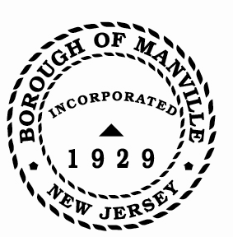
Borough of Manville
Resolution # 2025-16
Appointment of Municipal Court Judge- Francesco Taddeo

WHEREAS, the Hillsborough Township Committee has presented the name of Francesco Taddeo for the position of Municipal Court Judge for the Borough of Manville, for the Hillsborough-Montgomery-Manville Municipal Court.

NOW, THEREFORE, BE IT RESOLVED, by the Mayor and Council of the Borough of Manville, County of Somerset, State of New Jersey:

- that Francesco Taddeo is appointed to the position of Municipal Court Judge for the Borough of Manville [for the Hillsborough-Montgomery-Manville Shared Municipal Court] to a three (3) year term expiring 12/31/2027.

- that Francesco Taddeo shall forthwith upon the adoption of this Resolution, take an Oath of Office before a Judge of the N.J. Superior Court, in accord with New Jersey Court Rule 7:14-5 of the New Jersey Rules of Court, which requires that before entering upon the duties of the office, the oath of office of a municipal court judge shall be taken before a judge of the Superior Court, and which requires that the original of said oath shall be filed with the municipal court administrator and a copy of the original filed with the Administrative Director of the Courts.

ATTEST:

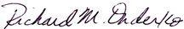
_________________
William Bray, RMC, CMR Richard M. Onderko
Borough Clerk Mayor

Introduced | Seconded | Council Members | Yes | No | Abstain | Absent
X |  | Councilwoman Camacho | X
 |  | Councilman DeVito | X
X |  | Councilman Lukac | X
 |  | Councilwoman Puia | X
 |  | Councilman Skirkanish | X
 |  | Councilwoman Zamorski | X
 |  | Mayor Onderko
I HEREBY CERTIFY that the foregoing Resolution was adopted by the Borough Council of the Borough of Manville, County of Somerset, State of New Jersey at a Regular Meeting held at 325 N. Main St., Manville, NJ 08835 on January 4, 2025.

ATTEST:

William Bray, RMC, CMR
Borough Clerk

