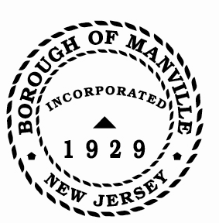
Borough of Manville
Resolution # 2025-15
Establishing Petty Cash Funds-2025

WHEREAS, the following individuals have been named custodians of petty cash funds for their respective departments; and

WHEREAS, the custodian names must be updated in accordance with N.J.S.A. 40:5-21; and

WHEREAS, the custodians named below are all bonded in the amount of $1,000,000 by virtue of a surety bond:

Office | Custodian | Amount of Fund
Police/Detective | Craig Jeremiah | $200.00
Police/General | Craig Jeremiah | $200.00
Tax Collector | David Marshall | $500.00

NOW, THEREFORE, BE IT RESOLVED, by the Mayor and Council of the Borough of Manville, County of Somerset, and State of New Jersey, hereby authorizes such action and two copies of this resolution be filed with the Division of Local Government Services, New Jersey Department of Community Affairs for approval.

ATTEST:

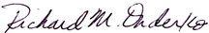
_________________
William Bray, RMC, CMR Richard M. Onderko
Borough Clerk Mayor

Introduced | Seconded | Council Members | Yes | No | Abstain | Absent
X |  | Councilwoman Camacho | X
 |  | Councilman DeVito | X
X |  | Councilman Lukac | X
 |  | Councilwoman Puia | X
 |  | Councilman Skirkanish | X
 |  | Councilwoman Zamorski | X
 |  | Mayor Onderko
I HEREBY CERTIFY that the foregoing Resolution was adopted by the Borough Council of the Borough of Manville, County of Somerset, State of New Jersey at a Regular Meeting held at 325 N. Main St., Manville, NJ 08835 on January 4, 2025.

ATTEST:

William Bray, RMC, CMR
Borough Clerk

