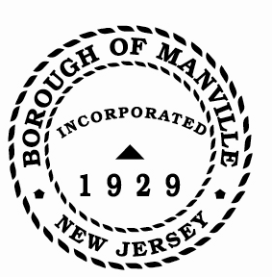
Borough of Manville
Resolution # 2025-12
Public Agency Compliance Officer

WHEREAS, the State of New Jersey, Division of Purchase and Property, Contract Compliance Audit Unit, EEO Monitoring Program, requires that municipalities name a Public Agency Compliance Officer (P.A.C.O.).

NOW, THEREFORE, BE IT RESOLVED by the Mayor and Council of the Borough of Manville, County of Somerset, and State of New Jersey, that the Borough Clerk is named as the Public Agency Compliance Officer for the Borough of Manville.

ATTEST:

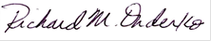
_________________
William Bray, RMC, CMR Richard M. Onderko
Borough Clerk Mayor

Introduced | Seconded | Council Members | Yes | No | Abstain | Absent
X |  | Councilwoman Camacho | X
 |  | Councilman DeVito | X
X |  | Councilman Lukac | X
 |  | Councilwoman Puia | X
 |  | Councilman Skirkanish | X
 |  | Councilwoman Zamorski | X
 |  | Mayor Onderko
I HEREBY CERTIFY that the foregoing Resolution was adopted by the Borough Council of the Borough of Manville, County of Somerset, State of New Jersey at a Regular Meeting held at 325 N. Main St., Manville, NJ 08835 on January 4, 2025.

ATTEST:

William Bray, RMC, CMR
Borough Clerk

