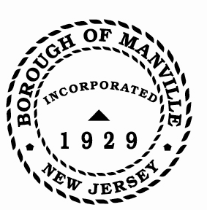
Borough of Manville
Resolution # 2025-04
Uncollected Tax/Utility Payments

WHEREAS, N.J.S.A. 40A:5-17-1 allows the Tax/Utility Collector to cancel tax/utility balances and/or tax/utility overpayments in the amount of $10.00 or less that remain uncollected at the close of the fiscal year.

NOW, THEREFORE, BE IT RESOLVED by the Mayor and Council of the Borough of Manville, County of Somerset, State of New Jersey that the Tax/Utility Collector of the Borough of Manville, is hereby authorized to cancel all tax receivables of $10.00 or less and all utility receivables of $5.00 or less for the year 2025.

ATTEST:

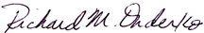
_________________
William Bray, RMC, CMR Richard M. Onderko
Borough Clerk Mayor

Introduced | Seconded | Council Members | Yes | No | Abstain | Absent
X |  | Councilwoman Camacho | X
 |  | Councilman DeVito | X
X |  | Councilman Lukac | X
 |  | Councilwoman Puia | X
 |  | Councilman Skirkanish | X
 |  | Councilwoman Zamorski | X
 |  | Mayor Onderko
I HEREBY CERTIFY that the foregoing Resolution was adopted by the Borough Council of the Borough of Manville, County of Somerset, State of New Jersey at a Regular Meeting held at 325 N. Main St., Manville, NJ 08835 on January 4, 2025.

ATTEST:

William Bray, RMC, CMR
Borough Clerk

