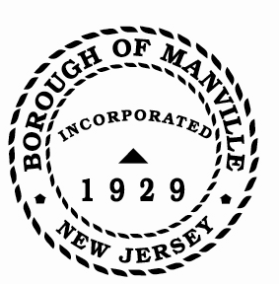
Borough of Manville
Resolution # 2025-03
Penalty on Tax Sale Certificate

WHEREAS, N.J.S.A. 54:5-61 relating to the amount of penalty to be charged on a tax sale certificate has been amended to read as follows:

“When taxes, interest and costs shall be in excess of $200.00, but less than $5,000.00, a two percent (2%) penalty on any amount due shall be charged. When taxes, interest and costs shall exceed the sum of $5,000.00, such additional sum shall be equal to four percent (4%) of such amount paid and when that sum exceeds $10,000.00 such additional sum paid shall be equal to six percent (6%) of such amount paid. This section shall also apply to all existing tax sale certificates held by municipalities on the effective date of this act.”

NOW, THEREFORE, BE IT RESOLVED by the Mayor and Council of the Borough of Manville, County of Somerset, State of New Jersey that under N.J.S.A. 54:4-61, the Tax Collector of the Borough of Manville is authorized to charge, on a tax sale certificate, a two percent (2%) penalty on any amount due in excess of $200.00 but less than $5,000.00; a four percent (4%) penalty on any amount due in excess of $5,000.00 but less than $10,000.00; and a six percent (6%) penalty on any amount due in excess of $10,000.00. These penalties are to be applied to all municipal held tax sale certificates as well as those which may be acquired by the municipality as a result of future tax sales.

FURTHERMORE, a copy of this resolution shall be forwarded to the Tax Collector.

ATTEST:

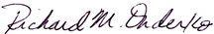
_________________
William Bray, RMC, CMR Richard M. Onderko
Borough Clerk Mayor

Introduced | Seconded | Council Members | Yes | No | Abstain | Absent
X |  | Councilwoman Camacho | X
 |  | Councilman DeVito | X
X |  | Councilman Lukac | X
 |  | Councilwoman Puia | X
 |  | Councilman Skirkanish | X
 |  | Councilwoman Zamorski | X
 |  | Mayor Onderko
I HEREBY CERTIFY that the foregoing Resolution was adopted by the Borough Council of the Borough of Manville, County of Somerset, State of New Jersey at a Regular Meeting held at 325 N. Main St., Manville, NJ 08835 on January 4, 2025.

ATTEST:

William Bray, RMC, CMR
Borough Clerk

