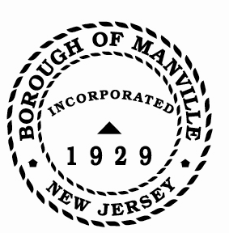
Borough of Manville
Resolution # 2025-02
Interest on Delinquent Tax/Utility Payments

WHEREAS, N.J.S.A. 54:4-67 governs the interest rates charged on delinquent Tax and Water/Sewer Utility payments.

NOW, THEREFORE, BE IT RESOLVED by the Mayor and Council of the Borough of Manville, County of Somerset, State of New Jersey that the interest rates charged on delinquent Tax and Water/Sewer Utility payments shall be eight percent (8%) for the first $1,500.00 of delinquency and eighteen percent (18%) thereafter, for the year 2025.

BE IT FURTHER RESOLVED that a copy of this resolution be forwarded to the Manville Tax Collector and the Manville Utility Collector.

ATTEST:

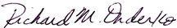
_________________
William Bray, RMC, CMR Richard M. Onderko
Borough Clerk Mayor

Introduced | Seconded | Council Members | Yes | No | Abstain | Absent
X |  | Councilwoman Camacho | X
 |  | Councilman DeVito | X
X |  | Councilman Lukac | X
 |  | Councilwoman Puia | X
 |  | Councilman Skirkanish | X
 |  | Councilwoman Zamorski | X
 |  | Mayor Onderko
I HEREBY CERTIFY that the foregoing Resolution was adopted by the Borough Council of the Borough of Manville, County of Somerset, State of New Jersey at a Regular Meeting held at 325 N. Main St., Manville, NJ 08835 on January 4, 2025.

ATTEST:

William Bray, RMC, CMR
Borough Clerk

