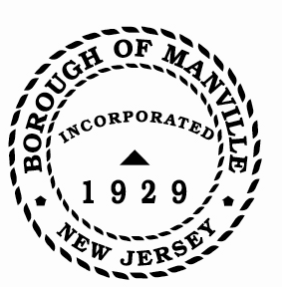
Borough of Manville
Resolution # 2025-01
2025 Depositories for Borough of Manville

WHEREAS, N.J.S.A. 40A:5-14 mandates that the Governing Body of a municipal corporation, shall, by resolution passed by a majority vote of the full membership thereof, designate as a depository for its monies, banks or trust companies having their places of business in the State and organized under the laws of the United States and this State.

NOW, THEREFORE, BE IT RESOLVED by the Mayor and Council of the Borough of Manville, County of Somerset, State of New Jersey that:

1) Fulton Bank of New Jersey, North Main Street, Manville, NJ 08835
2) TD Bank, 452 Union Avenue, Bridgewater, NJ 08835
3) Peapack Gladstone Bank, Bridgewater, NJ 08835
4) Investor’s Savings Bank, Somerset & North Brunswick, New Jersey
5) Citizens Bank, Somerset & North Brunswick, New Jersey
6) Any bank insured under the Government Units Deposit Protection Act

Be and are hereby designated as depositories for the Borough of Manville for the year ending December 31, 2025.

FURTHERMORE, prior to the deposit of any municipal funds in the afore-mentioned depositories, said entity shall file, with the Borough Treasurer, a statement indicating that the bank in insured under the Government Units Deposit Protection Act (R.S. 17:9-41).

ATTEST:

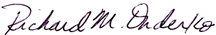
_________________
William Bray, RMC, CMR Richard M. Onderko
Borough Clerk Mayor

Introduced | Seconded | Council Members | Yes | No | Abstain | Absent
X |  | Councilwoman Camacho | X
 |  | Councilman DeVito | X
X |  | Councilman Lukac | X
 |  | Councilwoman Puia | X
 |  | Councilman Skirkanish | X
 |  | Councilwoman Zamorski | X
 |  | Mayor Onderko
I HEREBY CERTIFY that the foregoing Resolution was adopted by the Borough Council of the Borough of Manville, County of Somerset, State of New Jersey at a Regular Meeting held at 325 N. Main St., Manville, NJ 08835 on January 4, 2025.

ATTEST:

William Bray, RMC, CMR
Borough Clerk

