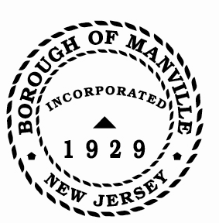
Borough of Manville
Resolution # 2025-08
GOVERNING BODY CERTIFICATION OF COMPLIANCE WITH THE
UNITED STATES EQUAL EMPLOYMENT OPPORTUNITY COMMISSION’S
“Enforcement Guidance on the Consideration of Arrest and Conviction Records in Employment Decisions Under Title VII of the Civil Rights Act of 1964”

WHEREAS, N.J.S.A. 40A:4-5 as amended by P.L. 2017, c.183 requires the governing body of each municipality and county to certify that their local unit’s hiring practices comply with the United States Equal Employment Opportunity Commission’s “Enforcement Guidance on the Consideration of Arrest and Conviction Records in Employment Decisions Under Title VII of the Civil Rights Act of 1964,” as amended, 42 U.S.C. § 2000e et seq., (April 25, 2012) before submitting its approved annual budget to the Division of Local Government Services in the New Jersey Department of Community Affairs; and

WHEREAS, the members of the governing body have familiarized themselves with the contents of the above-referenced enforcement guidance and with their local unit’s hiring practices as they pertain to the consideration of an individual’s criminal history, as evidenced by the group affidavit form of the governing body attached hereto.

NOW, THEREFORE BE IT RESOLVED, That the Mayor and Council of the Borough of Manville, County of Somerset, and State of New Jersey, hereby state that they have complied with N.J.S.A. 40A:4-5, as amended by P.L. 2017, c.183, by certifying that the local unit’s hiring practices comply with the above-referenced enforcement guidance and hereby directs the Clerk to cause to be maintained and available for inspection a certified copy of this resolution and the required affidavit to show evidence of said compliance.

ATTEST:

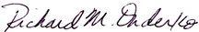
_________________
William Bray, RMC, CMR Richard M. Onderko
Borough Clerk Mayor

Introduced | Seconded | Council Members | Yes | No | Abstain | Absent
X |  | Councilwoman Camacho | X
 |  | Councilman DeVito | X
X |  | Councilman Lukac | X
 |  | Councilwoman Puia | X
 |  | Councilman Skirkanish | X
 |  | Councilwoman Zamorski | X
 |  | Mayor Onderko
I HEREBY CERTIFY that the foregoing Resolution was adopted by the Borough Council of the Borough of Manville, County of Somerset, State of New Jersey at a Regular Meeting held at 325 N. Main St., Manville, NJ 08835 on January 4, 2025.

ATTEST:

William Bray, RMC, CMR
Borough Clerk

