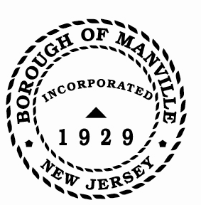
Borough of Manville
Resolution # 2025-07
Designating 2024 Official Newspapers for Borough of Manville

BE IT RESOLVED by the Mayor and Council of the Borough of Manville, County of Somerset, State of New Jersey that:

- The Courier News

Be and are hereby designated as official newspapers for the Borough of Manville for the year ending December 31, 2025.

ATTEST:

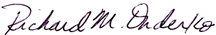
_________________
William Bray, RMC, CMR Richard M. Onderko
Borough Clerk Mayor

Introduced | Seconded | Council Members | Yes | No | Abstain | Absent
X |  | Councilwoman Camacho | X
 |  | Councilman DeVito | X
X |  | Councilman Lukac | X
 |  | Councilwoman Puia | X
 |  | Councilman Skirkanish | X
 |  | Councilwoman Zamorski | X
 |  | Mayor Onderko
I HEREBY CERTIFY that the foregoing Resolution was adopted by the Borough Council of the Borough of Manville, County of Somerset, State of New Jersey at a Regular Meeting held at 325 N. Main St., Manville, NJ 08835 on January 4, 2025.

ATTEST:

William Bray, RMC, CMR
Borough Clerk

