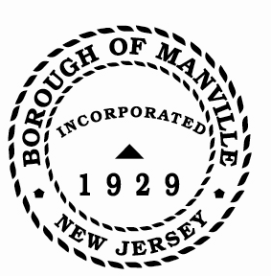
Borough of Manville
Resolution # 2025-06
Socially and Economically Disadvantaged Business

WHEREAS, the Borough of Manville has declared that the opportunity for all Socially and Economically Disadvantaged (SED) business concerns should exist for free entry into business, growth and exposure; and

WHEREAS, the Borough must ensure that a fair proportion of the Borough’s total purchases and contracts for construction, property supplies and services, etc. be placed with SED businesses. The policy hereby declared by the Borough of Manville shall not be inconsistent with the Set-Aside Act for SED businesses, N.J.S.A. 52:32-17, et. seq., Local Public Contract Law; N.J.S.A. 40A:11-41, et. seq., and the N.J. Wastewater Trust Act; N.J.S.A. 58:11-B-1, et. seq.

NOW, THEREFORE, BE IT RESOLVED by the Mayor and Council of the Borough of Manville, County of Somerset, State of New Jersey to implement this action and serve as a sponsor for these activities, the Governing Body hereby appoints the Borough Clerk to serve as “Public Agency Compliance Officer.”

BE IT FURTHER RESOLVED that a certified copy of this resolution be forwarded to Rohini Gandhi, Esq., Director of the Office of Equal Opportunity Public Contracts Assistance, N.J.D.E.P.

ATTEST:

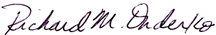
_________________
William Bray, RMC, CMR Richard M. Onderko
Borough Clerk Mayor

Introduced | Seconded | Council Members | Yes | No | Abstain | Absent
X |  | Councilwoman Camacho | X
 |  | Councilman DeVito | X
X |  | Councilman Lukac | X
 |  | Councilwoman Puia | X
 |  | Councilman Skirkanish | X
 |  | Councilwoman Zamorski | X
 |  | Mayor Onderko
I HEREBY CERTIFY that the foregoing Resolution was adopted by the Borough Council of the Borough of Manville, County of Somerset, State of New Jersey at a Regular Meeting held at 325 N. Main St., Manville, NJ 08835 on January 4, 2025.

ATTEST:

William Bray, RMC, CMR
Borough Clerk

