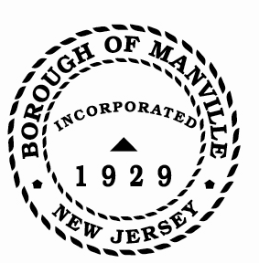
Borough of Manville
Resolution # 2025-05
Borough of Manville Department Heads

WHEREAS, it is legally essential that heads of various departments be responsible and sign for the receipt of material or the performance of any services on behalf of the Borough of Manville.

NOW, THEREFORE, BE IT RESOLVED by the Mayor and Council of the Borough of Manville, County of Somerset, State of New Jersey that the following heads of departments and other officials shall be and are responsible for the receipt of any merchandise shipped or performance of services delivered to the Borough of Manville, within their area of responsibility:

ADMINISTRATOR
CLERK
CHIEF OF POLICE
DIRECTOR OF PUBLIC WORKS
CHIEF FINANCE OFFICER
FIRE CHIEF
FIRE MARSHAL
HR/PAYROLL
TAX COLLECTOR
DIR. CODE ENFORCEMENT/ZONING OFFICER
RECREATION DIRECTOR
OEM DIRECTOR
TAX ASSESSOR

FURTHERMORE, that the above named are to affix the date showing when and where the said merchandise was received or the services performed; in the event of a discrepancy in the materials received or services performed, the Department Head is to report the same to the Chairman of the Committee in charge of the Department and the Purchasing Agent.

FURTHERMORE, the Borough Clerk is hereby authorized to send a copy of this resolution to the above-named Department Heads.

ATTEST:

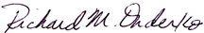
_________________
William Bray, RMC, CMR Richard M. Onderko
Borough Clerk Mayor

Introduced | Seconded | Council Members | Yes | No | Abstain | Absent
X |  | Councilwoman Camacho | X
 |  | Councilman DeVito | X
X |  | Councilman Lukac | X
 |  | Councilwoman Puia | X
 |  | Councilman Skirkanish | X
 |  | Councilwoman Zamorski | X
 |  | Mayor Onderko
I HEREBY CERTIFY that the foregoing Resolution was adopted by the Borough Council of the Borough of Manville, County of Somerset, State of New Jersey at a Regular Meeting held at 325 N. Main St., Manville, NJ 08835 on January 4, 2025.

ATTEST:

William Bray, RMC, CMR
Borough Clerk

