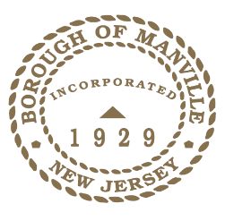
Proclamation
NATIONAL POW/MIA RECOGNITION DAY 2022

WHEREAS, in 1979 the families of missing Vietnam POW’s and MIA’s pressured Congress to increase their efforts to find answers, resulting in POW/MIA Recognition Day; and

WHEREAS, POW/MIA Recognition Day in New Jersey is an opportunity to honor and recognize our brave service members who are classified as either Prisoner of War or Missing in Action; and

WHEREAS, families, friends, and veterans still await recovery and identification of missing and unaccounted for service members from our Nation’s past wars and conflicts; and

WHEREAS, as one of the most veteran friendly towns in New Jersey, Manville supports, commands, and shares our Nation’s commitment to account as fully as possible for our service members still missing and unaccounted for; and

WHEREAS, World War II pilot, Newt Heisley designed the POW/MIA flag made in black and white to symbolize sorrow, anxiety, and hope, and has flown at all federal locations where the United States flag is flown; and

WHEREAS, on May 14, 2018,the Borough of Manville along with Rolling Thunder dedicated in honor of all POW’s and MIA’s the POW/MIA Chair of Honor that sits in the Council Meeting Room at Borough Hall.

NOW, THEREFORE BE IT RESOLVED, I Richard M. Onderko, Mayor of the Borough of Manville, County of Somerset, State of New Jersey along with the Borough Council hereby recognizes September 16, 2022 as National POW/MIA Recognition Day in the Borough of Manville and reminds all residents to remember those brave service men and women whose families still wait for either closure or to be reunited.

Borough of Manville
Richard M. Onderko, Mayor

Councilman Branden Agans Councilwoman Suzanne Maeder
Council President Joseph A. Lukac, III Councilman Ted Petrock
Councilwoman Barbara Madak Councilman Stephen Szabo

Read into Record: September 12, 2022

