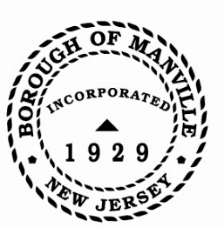
JUNETEENTH PROCLAMATION
BOROUGH OF MANVILLE

WHEREAS, on January 1, 1863, President Abraham Lincoln issued the Emancipation Proclamation, declaring the end of slavery in the United States, and

WHEREAS, it was not until June 19, 1865, that it was announced to those still enslaved in Texas: “The people are informed that. In accordance, with a proclamation from the Executive of the Untiled States, all slaves are free” ; and

WHEREAS, the celebration of the end of slavery, which became known as Juneteenth, is the oldest known public celebration of the end of slavery in the United States; and

WHEREAS, Juneteenth commemorates African American freedom and celebrates the successes gained through education and greater opportunity; and

WHEREAS, on June 17, 2021, President Biden officially declared June 19th as Juneteenth National Independence Day, a US federal holiday commemorating the end of slavery in the United States; and

WHEREAS, celebration of Juneteenth reminds each of us of the precious promises of freedom, equality, and opportunity which are at the core of the American Dream

NOW THEREFORE BE IT RESOLVED, I, Richard M. Onderko, Mayor of the Borough of Manville, County of Somerset, State of New Jersey along with the Council hereby recognize Juneteenth National Independence Day in the Borough of Manville and call upon its residents to become aware of the significance of this celebration in American history and in the heritage of our great nation.

Borough of Manville
Richard M. Onderko, Mayor

Councilman Branden Agans Councilwoman Suzanne Maeder
Council President Joseph A. Lukac, III Councilman Ted Petrock
Councilwoman Barbara Madak Councilman Stephen Szabo

Read into Record: June 13, 2022

