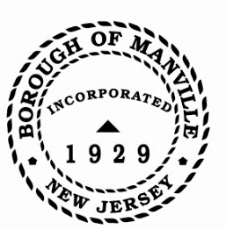
A PROCLAMATION DECLARING JUNE 2022 AS “PRIDE MONTH” IN THE BOROUGH OF MANVILLE
WHEREAS, the Borough of Manville recognizes that pursuant of equality, respect, and inclusion for all individuals is an attainable goal;
and

WHEREAS, the Borough of Manville is committed to promoting the visibility, dignity, and equality for LGBTQ+ individuals in our community and to fostering a welcoming and affirming LGBTQ+ spaces; and

WHEREAS, the Borough of Manville celebrates and encourages diversity and inclusion within our community; and

WHEREAS, the Borough of Manville recognizes the tireless dedication of advocates and allies who strived to forge a more inclusive community; and

WHEREAS, celebrating PRIDE MONTH influences awareness and provides support and advocacy for our LGBTQ+ community, and is an opportunity to build understanding and acceptance and advance equal rights; and

WHEREAS, by Presidential Proclamation as well at the State and County level, government leaders call upon the citizens of the United States, of New Jersey, and of Somerset County to commemorate PRIDE MONTH and celebrate the diversity of the American people and promote equal rights for all.

NOW THEREFORE BE IT RESOLVED, I, Richard M. Onderko, Mayor of the Borough of Manville, County of Somerset, State of New Jersey along with the Council hereby proclaim June 2022 as PRIDE MONTH in the Borough of Manville and call upon its residents to support efforts to eliminate discrimination, and support and celebrate the great diversity of all people.

Borough of Manville
Richard M. Onderko, Mayor

Councilman Branden Agans Councilwoman Suzanne Maeder
Council President Joseph A. Lukac, III Councilman Ted Petrock
Councilwoman Barbara Madak Councilman Stephen Szabo

Read into Record: June 13, 2022

