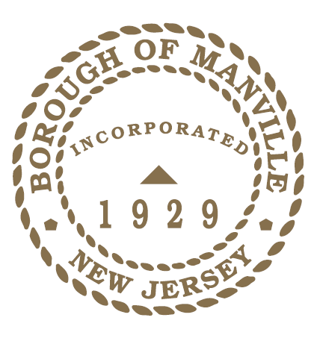
BOROUGH OF MANVILLE
VOLUNTEER APPRECIATION WEEK 2022

WHEREAS, since the early days of our nation, volunteers have played a vital role in our greatest challenges and triumphs- from patriots who fought for our founding freedom, to men and women who support our country in times of war and peace, to neighbors who come to the aid of their neighbors during times of need and crisis, to individuals who contribute to civic organizations, schools, and places of worship; and
WHEREAS, the Borough’s volunteers are an integral part in addressing local issues and demonstrate that it is possible to bring people together in response to our community’s critical needs ; and
WHEREAS, the National Volunteer Week theme for 2022, Volunteering Is Empathy In Action, affirms the strong connection between volunteerism and empathy. This profoundly human connection is at the heart of healthier individuals and stronger communities; and
WHEREAS, Volunteer Appreciation Week provides an opportunity recognize the individuals who selflessly give of their time and talents; and
WHEREAS, engaged community members are improving the lives of our Borough’s residents by preserving the environment, mentoring and teaching the Borough’s children and teenagers, supporting veterans, and contributing to public safety by responding to disasters; and
WHEREAS, in 2021 the Borough of Manville’s volunteers ranged from serving on civic boards and committees, to the firemen and first aid volunteers, to those coaching youth sports programs or Girl or Boy Scout leaders to residents who during Hurricane Ida came together to help those so severely impacted by its rath.; and
WHEREAS, it is the moral duty of every citizen and leader to honor our dedicated volunteers and celebrate all the volunteer programs that contribute to the quality of life not only here in the Borough of Manville but for the County of Somerset and State of New Jersey.
NOW THEREFORE, I Richard M. Onderko, Mayor of the Borough of Manville, County of Somerset, State of New Jersey along with the Council do hereby proclaim April 23rd- April 30th as Volunteer Appreciation Week in the Borough of Manville and urge all residents to join the Borough of Manville in recognizing those selfless, committed individuals.
Borough of Manville
Richard M. Onderko, Mayor

Councilman Branden Agans Councilwoman Suzanne Maeder
Council President Joseph A. Lukac, III Councilman Ted Petrock
Councilwoman Barbara Madak Councilman Stephen Szabo
Read into the Record: April 25, 2022

