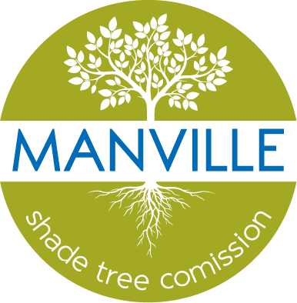

borough of Manville
ARBOR DAY 2022 PROCLAMATION

WHEREAS, in 1872, J. Sterling Morton proposed to the Nebraska Board of Agriculture that a special day be set aside for the planting of trees; and
WHEREAS, this holiday, called Arbor Day, was first observed with the planting of more than a million trees in Nebraska; and
WHEREAS, Arbor Day is now observed throughout the nation and the world; and
WHEREAS, trees can reduce the erosion of our precious topsoil by wind and water, cut heating and cooling costs, moderate the temperature, clean the air, produce life-giving oxygen, and provide habitat for wildlife; and
WHEREAS, trees in our town increase property values, enhance the economic vitality of business areas, and beautify our community; and
WHEREAS, trees, wherever they are planted, are a source of joy and spiritual renewal.
NOW, THEREFORE, I, RICHARD M. ONDERKO, Mayor of the Borough of Manville, along with the Borough Council hereby proclaim April 29, 2022 as Arbor Day in the Borough of Manville and I urge all citizens to celebrate Arbor Day and to support efforts to protect our trees and woodlands; and
FURTHER I urge all citizens to plant trees to promote the well-being of this and future generations.
Borough of Manville
Richard M. Onderko, Mayor
Councilman Branden Agans Councilwoman Suzanne Maeder
Council President Joseph A. Lukac, III Councilman Ted Petrock
Councilwoman Barbara Madak Councilman Stephen Szabo
Read into the Record: April 25, 2022

