BOROUGH OF MANVILLE
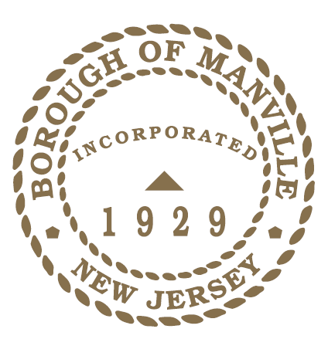
PROCLAMATION COMMENDING THE LIFE AND ACCOMPLISHMENTS OF NED PANFILE AND EXPRESSING DEEPEST SYMPATHY TO HIS FAMILY AND FRIENDS UPON HIS PASSING.

WHEREAS, Ned Panfile, born November 5, 1936, departed this earthly life on April 5, 2022, causing great sorrow and loss to his family and friends; and

WHEREAS, a graduate of University of Scranton and Kean University, Mr. Panfile was a diligent and dedicated educator with the Manville School District and served as Vice Principal at Manville High School until his retirement in 2001; and

WHEREAS, in addition to being an educator, Mr. Panfile was a baseball, wrestling, and football coach at Manville High School and a freshman football coach at Princeton University. In 1968, he coached the Mustangs to a 9-0 record in football and coached the Baseball team to a 21-2 record and won the CJ Group 1 and Mountain Valley Conference Title. In 1993, he returned to Manville as an Asst. Football Coach until 2018; and

WHEREAS, in 2000 the Manville High School Football Field was renamed Ned Panfile Stadium in his honor for his outstanding dedication to Manville High School and the sports program. He was inducted into the NJFCA Coaches Hall of Fame in 2011 ; and

WHEREAS, he was very active in civic and community organizations, having served on the Board of Education for 16 years and was a member of the Manville Senior’s Club, a founding member of the Manville Quarterback club, and served on the Board of Health and Manville Municipal Alliance Committee; and

WHEREAS, it is the policy of this Council to pay special tribute to such an outstanding individual as Mr. Panfile, whose service and dedication to the Borough of Manville will forever be etched in the hearts and memories of those whose lives he touched.

NOW THEREFORE I, Richard M. Onderko, Mayor of the Borough of Manville, County of Somerset, State of New Jersey along with the Council do hereby commend the life and accomplishments of Mr. Ned Panfile and express deepest sympathy to his family and friends upon his passing.

Borough of Manville
Richard M. Onderko, Mayor
Councilman Branden Agans Councilwoman Suzanne Maeder
Council President Joseph A. Lukac, III Councilman Ted Petrock
Councilwoman Barbara Madak Councilman Stephen Szabo
Read into the Record: April 11, 2022

