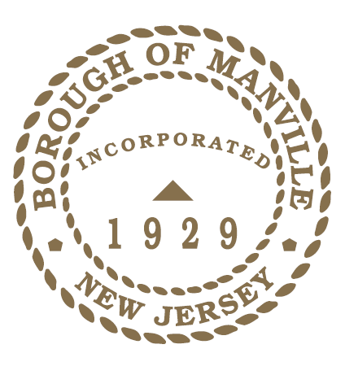
borough of Manville
World Autism Awareness Day 2022-LIGHT IT UP BLUE
PROCLAMATION

WHEREAS, World Autism Awareness Day was designated by the United Nations in 2007 in an effort to send stigmatization and discrimination against those with autism; and

WHEREAS, Autism Spectrum Disorder is a complex developmental disorder affecting the social, communication and behavioral skills of those affected by it and while most symptoms are likely to be apparent in children as young as two years old, many people do not receive an official diagnosis until later in life; and

WHEREAS, as more health professionals become proficient in diagnosing autism, more children are being diagnosed on the autism spectrum, resulting in rates a high as 1 in 44 children nationally and 1 in 35 in New Jersey; and

WHEREAS, while there is no cure for autism spectrum disorder, it is well-documented that if individuals with autism receive early and intensive treatment throughout their lives, they may lead significantly improved lives; and

WHEREAS, individuals with autism often require a lifetime of specialized and community-support services to ensure their health and safety to support families’ resilience as they manage the psychological and financial challenges autism can present; and

NOW THEREFORE I, Richard M. Onderko, Mayor of the Borough of Manville, County of Somerset, State of New Jersey along with the Council do hereby proclaim April 2, 2022 as World Autism Awareness Day in the Borough of Manville and urge all employees and residents to wear and light it up blue, to become better educated about autism spectrum disorder and create a better community for individuals with autism.

Borough of Manville
Richard M. Onderko, Mayor
Councilman Branden Agans Councilwoman Suzanne Maeder
Council President Joseph A. Lukac, III Councilman Ted Petrock
Councilwoman Barbara Madak Councilman Stephen Szabo
Read into the Record: March 28, 2022

