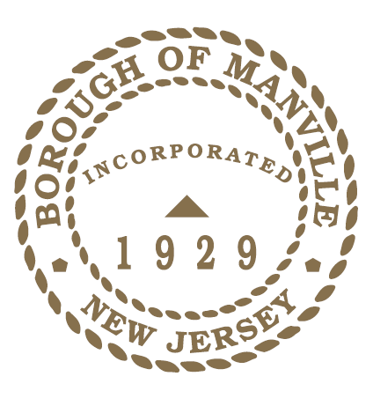
BOROUGH OF MANVILLE
GIRL SCOUT DAY PROCLAMATION 2022

WHEREAS March 12, 2022, marks the 110th anniversary of Girl Scouts of the USA, the largest and most successful leadership program for girls in the world; and
WHEREAS, as the world’s premier leadership development organization for girls, Girl Scouts has emphasized public service, civic engagement, and fostering a sense of community in girls for over a century; and
WHEREAS, Girl Scouts works to champion the ambitions, cultivate the talents, and develop the skills of girls to be leaders in their own world, and in ours; and
WHEREAS, in these incredibly challenging times, Girl Scouts provides community, consistency, and connection for girls, and is a safe haven in all the uncertainty; and
WHEREAS, this year, the theme is “Our World: Our Equal Future: The Environment and Gender Equality.” To bring attention how girls and women are disproportionately affected by climate change and to participate in the Girl Scout Tree Promise.; and
WHEREAS, at a time when civics education is missing from many schools, Girl Scouts has introduced new K-12 Civics badges to bring girls more experiences that deepen their understanding of democracy and government, prepare them for a lifetime of civic engagement, and motivate them to be catalysts for change; and
WHEREAS, Girl Scouts offers girls 21st century programming in science, technology, engineering, and math; the outdoors, entrepreneurship; and beyond, helping girls develop invaluable life skills and take the lead early and often; and
WHEREAS, Gold Award Girl Scouts already take on projects that have a measurable and sustainable impact on a community by first assessing a need, designing a solution, completing a project, and inspiring others to sustain it; and
WHEREAS, today, more than 50 million women are Girl Scout alums: and
WHEREAS there are approximately 30 Girl Scouts within the Borough of Manville who belong to Unit #68, Girl Scout Heart of New Jersey; and
NOW THEREFORE, I Richard M. Onderko, Mayor of the Borough of Manville, County of Somerset, State of New Jersey along with the Council do hereby applaud the Girl Scout Movement and Service Unit #68 for providing girls with a safe, inclusive, all-girl space where they can hone their skills and develop leadership abilities, and I declare March 12, 2022 to be Girl Scout Day in the Borough of Manville.
Borough of Manville
Richard M. Onderko, Mayor

Councilman Branden Agans Councilwoman Suzanne Maeder
Council President Joseph A. Lukac, III Councilman Ted Petrock
Councilwoman Barbara Madak Councilman Stephen Szabo
Read into the Record: February 28, 2022

