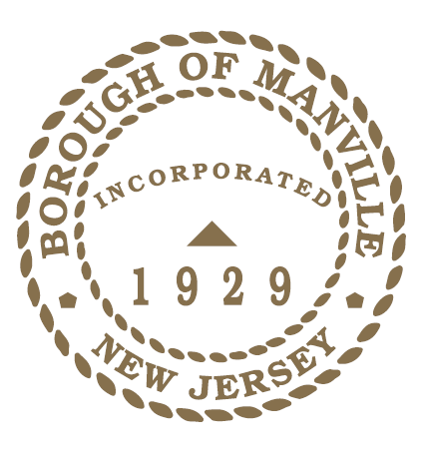
borough of Manville
American Red Cross Month 2022 proclamation

WHEREAS, throughout our country’s history, the humanitarian spirit of the American people has shined as a beacon of hope in times of crisis. It is in that spirit that we celebrate American Red Cross Month, a chance to honor all those selfless Americans who step up and lend a hand whenever and wherever people are in need; and

WHEREAS, for 140 years, the American Red Cross has been synonymous with the prevention and alleviation of human suffering across the globe. Founded by Clara Barton in 1881, the organization’s mission lives on in the dedication of Red Cross workers — more than 90 percent of whom are volunteers — and the generosity of the American people in moments of crisis; and

WHEREAS, we saw unmistakable evidence of that spirit through the challenges of this past year. In 2021, more than 70,000 people became new Red Cross volunteers and stepped up on behalf of those in need — as disaster shelter workers, health workers, blood donor ambassadors, and transportation specialists. And when our country faced a severe blood shortage, the American people rolled up their sleeves, with more than a half-million of our friends and neighbors donating blood with the Red Cross for the first time; and

WHEREAS, in a year like no other, people made a lifesaving difference. As months of relentless hurricanes, wildfires, and other extreme weather events battered communities, families spent more nights in emergency lodging than in any other year over the past decade — thanks to the hard work and generosity of Red Cross volunteers and partners who provided more than 1.3 million people with overnight stays last year; and

WHEREAS, here in Manville, the American Red Cross came to the aid of those residents affected by Hurricane Ida, providing emergency shelter, food, and life sustaining supplies in the days following; and

NOW, THEREFORE I, Richard M. Onderko, Mayor of the Borough of Manville, County of Somerset, State of New Jersey along with the Council hereby proclaim March 2022 as American Red Cross Month and encourage all residents to observe this month with appropriate programs, ceremonies, and activities, and by supporting the work of service and relief organizations.

Borough of Manville
Richard M. Onderko, Mayor

Councilman Branden Agans Councilwoman Suzanne Maeder
Council President Joseph A. Lukac, III Councilman Ted Petrock
Councilwoman Barbara Madak Councilman Stephen Szabo
Read into the Record: February 28, 2022

