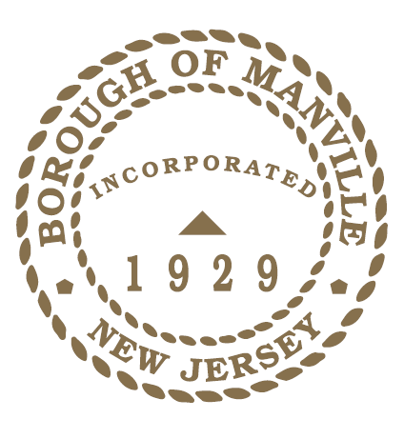
BOROUGH OF MANVILLE
WOMEN’S HISTORY MONTH 2022 PROCLAMATION

WHEREAS, each year, Women’s History Month offers an important opportunity for us to shine a light on the extraordinary legacy of trailblazing American women and girls who have built, shaped, and improved upon our Country; and

WHEREAS, throughout American history, women and girls have made vital contributions, often in the face of discrimination and undue hardship. Courageous women marched for and won the right to vote, campaigned against injustice, shattered countless barriers, and expanded the possibilities of American life; and

WHEREAS, our history is also replete with examples of the unfailing bravery and grit of women in America, particularly in times of crisis and emergency. Women served our Nation during World War II, led organizing and litigation efforts during the Civil Rights movement, and represented the United States on the global stage in the fight for human rights, peace, and security; and

WHEREAS, far too often, their heroic efforts and their stories have gone untold — especially the millions of Black women, immigrant women, and others from diverse communities who have strengthened America across every generation; and

WHEREAS, in the current moment of crisis, women continue to lead. From vaccine researchers to public health officials to the countless heroines on the frontlines, women are working around the clock to defeat COVID-19; and

WHEREAS, Women, also make up the majority of America’s essential workers, including educators and child care providers, grocery store workers, farmworkers, and others who are keeping our families, our communities, and our country afloat; and

WHEREAS, March 8th is International Women’s Day and the theme for 2022 is “Providing Healing, Promoting Hope,” and is both a tribute to the ceaseless work of caregivers and frontline workers during this ongoing pandemic and also a recognition of the thousands of ways that women of all cultures have provided both healing and hope throughout history.

NOW THEREFORE, I Richard M. Onderko, Mayor of the Borough of Manville, County of Somerset, State of New Jersey hereby along with the Council proclaim March 2022 as Women’s History Month in the Borough of Manville.

Borough of Manville

Richard M. Onderko, Mayor

Councilman Branden Agans Councilwoman Suzanne Maeder
Council President Joseph A. Lukac, III Councilman Ted Petrock
Councilwoman Barbara Madak Councilman Stephen Szabo
Read into the Record: February 28, 2022

